**Dog Salon Database Design Document**

**Submittal Date:**

**Table of Contents**

**Topic Page**

**Purpose ….……………………………………………………………..………... 4**

**Narrative ...………………………………………………………...……………. 4**

**Requirements (Actors/Roles) …..……………………………………………… 5**

**Entities …………………….………...…………………………….……………. 6**

**Entities (w/ Nested Attributes) …………………………………..……………. 7**

**Business Rules ……………………………………………………….……...…. 8**

**ERD …………………………………….……………………………………….. 9**

**EERD ……………………………………….………………………………….. 10**

**Relational Schema ……………………………………….……………………. 11**

**Purpose**

The purpose of this Database Design Documentation (DBDD) is to keep track of every business process that happens between the Dapper Dog Salon (DDS) which provides services that customers select for their dogs to receive and the DDS purchasing products from wholesale groomer supply stores to provide products and services to the dogs. To track all such happenings of the DDS, it is important to document this entire process within an organized database.

**Narrative**

Dapper Dog Salon is a pet salon located in the Tampa Bay area that serves many customers every day. They pride themselves on ensuring that every dog that visits their shop leaves looking better and smelling cleaner, with a wagging tail of satisfaction. The Salon wants to design a database to track the business process described below.

Dapper Dog Salon tracks their customers (dog owners). They register each customer to keep their information up to date and to have the ability to contact customers. The Salon tracks each customer’s name, address, phone number, email.

The Salon also tracks each dog’s name, breed, temperament, date of birth, and age. Dogs are owned by customers. A customer can have more than one dog. A dog can be picked up by a customer or an authorized family member. Family members are registered to a customer for pickup permission which allows them to access their family’s dog(s) at the salon.

The Salon purchases products from wholesale groomer supply stores. The product information is tracked by product number and the product description such as shampoo, styling tools, bows, nail clippers, combs, and other similar items.

The Salon has a list of wholesale groomer supply stores that they purchase from. The orders come directly from the supplier. They track the name, address, and phone number of the supplier. Some suppliers offer more than one item and some items come from more than one supplier.

The Salon provides services that customers select for their dogs to receive. The services are tracked by type and description of service. The Salon wants to track which products are used for which service, so they can be efficient in product ordering. Some services use no products, while other services may use more than one. A product may have multiple uses for different services. They also want to track which employees provide which services to which dogs on which dates. Services offered such as washes, haircuts, hair styles, nail trimming, nail painting, and flea treatments. Customers have the option to arrange a set of preferred services for their dog that are automatically performed whenever a dog is dropped off.

The Salon maintains simple employee information: name, address and phone number. An employee may perform one or more services for a dog.

**Requirements (Actors and Roles)**

Customer: Customers owns the dogs. A customer can have more than one dog.

Family Member: Family members are registered to a customer for pickup permission to access their family’s dog at the salon.

Dog: Dogs are owned by the customers. A customer can have more than one dog and the dog can be picked up by a customer or an authorized family member.

Service: Services are provided to the customers to select for their dogs to receive. Some services use no products while other services require more than one.

Employee: Employees provide the services to the dogs.

Product: Products are purchased from the suppliers. A product may have multiple uses for different services.

Supplier: Supplier provides the products to the Salon. Some suppliers offer more than one item and some items come from more than one supplier.

**Entities**

* Customer
* Family Member
* Dog
* Service
* Employee
* Product
* Supplier

**Entities w/ Nested Attributes**

* Customer
  + Customer ID
  + Cust Name
  + Address
  + Phone Number
  + Email
* Family Member
  + Family ID
  + Family Name
  + Phone Number
* Dog
  + Dog ID
  + Dog Name
  + Breed
  + Temperament
  + DOB
  + Age
* Service
  + Service ID
  + Desc
  + Service Type
* Employee
  + Employee ID
  + Employee Name
  + Employee Address
* Product
  + Product ID
  + Product Name
  + Prod Desc
  + Prod Available
* Supplier
  + Supplier ID
  + Supplier Name

**Business Rules**

Customer: Customer can have more than one dog. Customers have the option to arrange a set of preferred services for their dog.

Family Member: Family members can be zero, one or more who are registered to a customer for pickup permission of their dog.

Dog: Dogs are owned by the customers. A dog can have only one owner (Customer). Dog is picked up by a customer or an authorized family member.

Service: Services may use no product or use one or more products. Services can be provided on zero, one or more than one dog.

Employee: One or more than one employee may provide one or many services on zero, one or more dogs.

Product: One or more products come from a single supplier or from more than one supplier. A product may be used for one or more than one service.

Supplier: Supplier may offer zero, one or more than one item (Product) and some items come from more than one supplier.

**ERD**

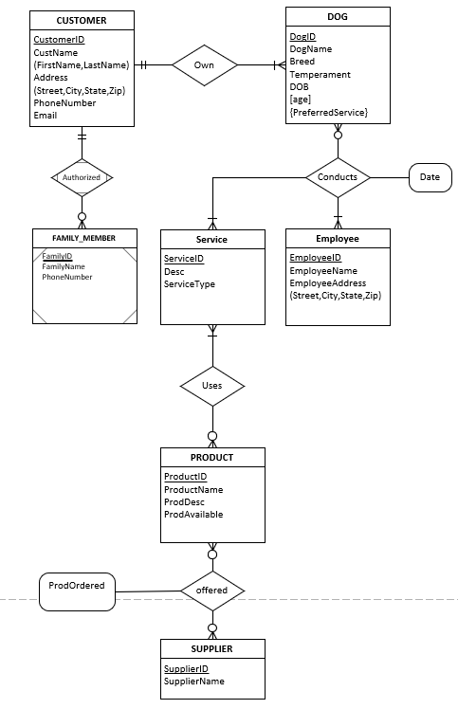

**EERD**

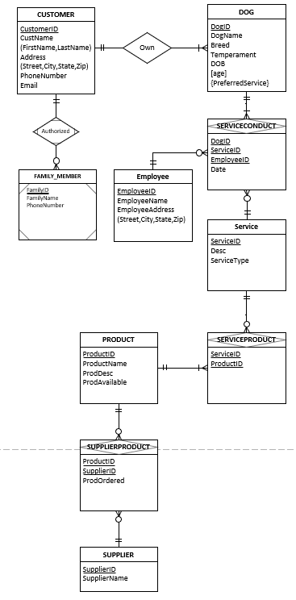

**Relational Schema**

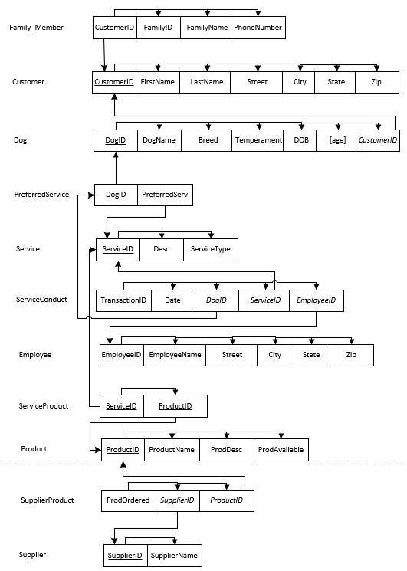

**Data Dictionary**

**Table:** Customer

|  |  |  |  |  |  |  |  |  |  |
| --- | --- | --- | --- | --- | --- | --- | --- | --- | --- |
| **Column Name** | **Description** | **Data**  **type** | **Size** | **Identity** | **Unique** | **Default** | **Check** | **Allow Nulls** | **Index** |
| CustomerID | **PK**; Unique Customer ID number | int |  | Y | Y |  |  |  | Y |
| FirstName | First name of the customer | varchar | 20 |  |  |  |  |  |  |
| LastName | Last name of the customer | varchar | 20 |  |  |  |  | Y |  |
| Street | Street Address of the Customer | varchar | 20 |  |  |  |  | Y |  |
| City | City of the Customer | varchar | 20 |  |  |  |  |  |  |
| State | State of the Customer | Char | 2 |  |  |  | ([State] like '[A-Z] [A-Z]') |  |  |
| Zip | Zip code of the Customer | Char | 5 |  |  |  | ([Zip] like '[0-9] [0-9] [0-9] [0-9] [0-9]') |  |  |
| Email | Email of the Customer | varchar | 20 |  |  |  |  | Y |  |

**Table:** Dog

|  |  |  |  |  |  |  |  |  |  |
| --- | --- | --- | --- | --- | --- | --- | --- | --- | --- |
| **Column Name** | **Description** | **Data**  **type** | **Size** | **Identity** | **Unique** | **Default** | **Check** | **Allow Nulls** | **Index** |
| DogID | **PK**; Unique dog ID number | int |  | Y | Y |  |  |  | Y |
| DogName | Name of the Dog | varchar | 20 |  |  |  |  |  |  |
| Breed | Breed of the dog | varchar | 20 |  |  |  |  | Y |  |
| Temperament | Temperament of the dog | varchar | 20 |  |  |  |  | Y |  |
| DOB | Date of Birth | date |  |  |  |  |  |  |  |
| Age | Age of the dog |  |  |  |  |  |  |  |  |
| CustomerID | **FK**; Unique Customer ID number | int |  |  |  |  |  |  |  |

**Table:** PreferredService

|  |  |  |  |  |  |  |  |  |  |
| --- | --- | --- | --- | --- | --- | --- | --- | --- | --- |
| **Column Name** | **Description** | **Data**  **type** | **Size** | **Identity** | **Unique** | **Default** | **Check** | **Allow Nulls** | **Index** |
| DogID | **CPK**; FK to dog table | int |  | Y | Y |  |  |  | Y |
| PreferredServ | **CPK**; Preferred set of services | varchar | 20 |  |  |  |  |  |  |

**Table:** Family_Member

|  |  |  |  |  |  |  |  |  |  |
| --- | --- | --- | --- | --- | --- | --- | --- | --- | --- |
| **Column Name** | **Description** | **Data**  **type** | **Size** | **Identity** | **Unique** | **Default** | **Check** | **Allow Nulls** | **Index** |
| FamilyID | **PK**; Unique family ID number | int |  | Y | Y |  |  |  | Y |
| FamilyName | Name of the family member | varchar | 20 |  |  |  |  |  |  |
| PhoneNumber | Phone Number of the family member | int |  |  |  |  |  |  |  |
| CustomerID | **FK**; Unique Customer ID number | int |  |  |  |  |  |  |  |

**Table:** Service

|  |  |  |  |  |  |  |  |  |  |
| --- | --- | --- | --- | --- | --- | --- | --- | --- | --- |
| **Column Name** | **Description** | **Data**  **type** | **Size** | **Identity** | **Unique** | **Default** | **Check** | **Allow Nulls** | **Index** |
| ServiceID | **PK**; Unique Service ID number | int |  | Y | Y |  |  |  | Y |
| Desc | Description of the service | char | 20 |  |  | [ServiceType] |  |  |  |
| ServiceType | Type of the service | Varchar | 20 |  |  |  | ([ServiceType] = ‘washes’  OR  [ServiceType] = ‘haircuts’  OR  [ServiceType] = ‘hairstyles’  OR  [ServiceType] = ‘nailtrimming’  OR  [ServiceType] = ‘nailpainting’  OR  [ServiceType] = ‘fleatreatments’) |  |  |

**Table:** ServiceConduct

|  |  |  |  |  |  |  |  |  |  |
| --- | --- | --- | --- | --- | --- | --- | --- | --- | --- |
| **Column Name** | **Description** | **Data**  **type** | **Size** | **Identity** | **Unique** | **Default** | **Check** | **Allow Nulls** | **Index** |
| Date | Date of the service conducted | date |  |  |  |  |  |  |  |
| DogID | **FK** to dog table | int |  |  |  |  |  |  |  |
| ServiceID | **FK** to service table | int |  |  |  |  |  |  |  |
| EmployeeID | **FK** to employee table | int |  |  |  |  |  |  |  |

**Table:** Product

|  |  |  |  |  |  |  |  |  |  |
| --- | --- | --- | --- | --- | --- | --- | --- | --- | --- |
| **Column Name** | **Description** | **Data**  **type** | **Size** | **Identity** | **Unique** | **Default** | **Check** | **Allow Nulls** | **Index** |
| ProductID | **PK;** Unique product ID number | int |  | Y | Y |  |  |  | Y |
| ProdName | Name of the product | varchar | 20 |  |  |  |  |  |  |
| ProdDesc | Street of the employee | varchar | 50 |  |  |  |  |  |  |
| ProdAvailable | City of the employee | char | 2 |  |  |  | [ProdAvailable] =‘Y’ OR  [ProdAvailable] = ‘N’ |  |  |

**Table:** Employee

|  |  |  |  |  |  |  |  |  |  |
| --- | --- | --- | --- | --- | --- | --- | --- | --- | --- |
| **Column Name** | **Description** | **Data**  **type** | **Size** | **Identity** | **Unique** | **Default** | **Check** | **Allow Nulls** | **Index** |
| EmployeeID | **PK;** Unique Employee ID number | int |  | Y | Y |  |  |  | Y |
| EmployeeName | Name of the employee | varchar | 20 |  |  |  |  |  |  |
| Street | Street of the employee | varchar | 20 |  |  |  |  | Y |  |
| City | City of the employee | varchar | 10 |  |  |  |  |  |  |
| State | State of the employee | char | 2 |  |  |  | ([State] like '[A-Z] [A-Z]') |  |  |
| Zip | Zip code of the employee | char | 5 |  |  |  | ([Zip] like '[0-9] [0-9] [0-9] [0-9] [0-9]') |  |  |
| Email | Email of the employee | varchar | 20 |  |  |  |  | Y |  |

**Table:** ServiceProduct

|  |  |  |  |  |  |  |  |  |  |
| --- | --- | --- | --- | --- | --- | --- | --- | --- | --- |
| **Column Name** | **Description** | **Data**  **type** | **Size** | **Identity** | **Unique** | **Default** | **Check** | **Allow Nulls** | **Index** |
| ServiceID | **FK** to service table | int |  |  |  |  |  |  |  |
| ProductID | **FK** to product table | int |  |  |  |  |  |  |  |

**Table:** SupplierProduct

|  |  |  |  |  |  |  |  |  |  |
| --- | --- | --- | --- | --- | --- | --- | --- | --- | --- |
| **Column Name** | **Description** | **Data**  **type** | **Size** | **Identity** | **Unique** | **Default** | **Check** | **Allow Nulls** | **Index** |
| ProdOrdered | Ordered products | date |  |  |  |  |  |  |  |
| SupplierID | **FK** to supplier table | int |  |  |  |  |  |  |  |
| ProductID | **FK** to product table | int |  |  |  |  |  |  |  |

**Table:** Supplier

|  |  |  |  |  |  |  |  |  |  |
| --- | --- | --- | --- | --- | --- | --- | --- | --- | --- |
| **Column Name** | **Description** | **Data**  **type** | **Size** | **Identity** | **Unique** | **Default** | **Check** | **Allow Nulls** | **Index** |
| SupplierID | **PK**; Unique supplier ID number | int |  | Y | Y |  |  |  | Y |
| SupplierName | Name of the supplier | varchar | 20 |  |  |  |  |  |  |

**Database Diagram**

